Coventry Road Practice
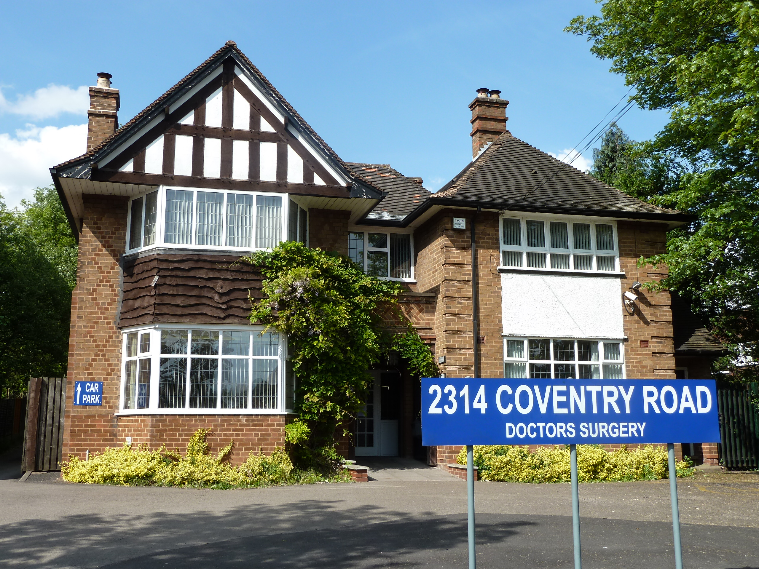
A guide to
our services

2314 Coventry Road, Sheldon, Birmingham B26 3JS

Telephone: 0121 743 2154

www.coventryroadpractice.co.uk

Opening hours: Monday to Friday: 8am until 6.30pm

Out of Hours Emergencies: Please call 111

This practice is within the NHS Birmingham & Solihull Integrated Care System (ICS) area

Welcome
Coventry Road Practice accepts and retains patients within what the practice considers to be a reasonable distance of the Practice address. Although patients may be taken on at the fringes of our "area", (this is at the discretion of the Partners), it should be remembered that the further you live from the surgery the more difficult it may be for you to access services.

Our team includes four GPs, two practice nurses and two health care assistants as well as our practice manager and reception staff.

We offer a full general practice service and run specialist clinics for children and pregnant women, diabetes and asthma sufferers and for patients needing minor surgery.

At Coventry Road Practice, we aim to treat all our patients promptly, courteously and in complete confidence.

If you live in our practice area and would like to register with us, please complete a registration form on our website.

Accessible Standards
If you have any problems with communication please let the surgery know. We aim to identify, record and meet your communication needs.

Clinics
We run a range of clinics. For an appointment or further details, please call contact us on (0121) 743 2154 or visit our website.

Antenatal
Thursday (usually 1st & 3rd Thursday in the month) fortnightly
This clinic is run by the midwives. If you become pregnant your details will be passed to the community midwife who will initially contact you at home and will ask you a few questions and carry out some general health checks. You will be seen regularly throughout your pregnancy either at the practice or at the local hospital, or both.

Child health and immunisation
By appointment
All new babies are invited for regular check-ups from eight weeks old at the surgery.

Minor surgery
By appointment
Steroid injections can be done in our treatment room and minor operations. Please discuss this with your doctor who will then arrange for you to be given an appointment.

Diabetes
By appointment
Led by Dr Vino Ganespathy, this clinic offers advice and general health check-ups to patients diagnosed with diabetes.

Asthma

By appointment
Asthma sufferers can attend this clinic for advice and support from our nurse who specialises in asthma care, and we recommend you do have a review with the Nurse at least once a year.

Stopping smoking

By appointment
Run by our nurses and healthcare assistant, this clinic gives advice and support to patients trying to give up smoking.

Family Planning

By appointment
For contraceptive advice please make an appointment with one of the Doctors or practice nurse. If you require a contraceptive implant or coil we will arrange this to be done at the surgery. Also you can obtain advise and emergency assistance from the Umbrella Service at https://umbrellahealth.co.uk/ or by calling 0121 237 5700

Health Visitor
If you live in Solihull you can contact your local Health Visitor on 0121 704 3405. If you live in Birmingham you can contact your local Health Visitor on 0121 465 1863.

Allocated GP

From the 1st April 2015 practices are required under their contract to allocate a named GP to ALL patients including children. All patients at the surgery have been allocated a named GP who is responsible for generally over seeing your medical care but for your day to day consultations if your named GP is not available you can continue to see any Doctor within the practice.

As a patient, you do not have to take any further action but if you have any queries regarding this please do not hesitate to contact the Practice Manager to discuss this further.

If you would like to know who your allocated GP is please ask at Reception.

Prescriptions

Repeat prescriptions
At least 2 working days is needed for repeat prescriptions. Please post or hand in your repeat slip at the surgery or order via our on-line access. Several local chemists offer a collection service. Please ask at reception for details.

On-line Access

The Practice offer on-line facilities for patients to book appointments, order medication, view allergies and view full information in their medical records. Speak to a Receptionist to get your personal log in details (photo ID required).

Specialist and hospital care

If a GP or another member of our health care team believes you need hospital treatment or specialist care elsewhere, they will refer to one of the local hospitals.

Appointments
You may book an appointment by ringing (0121) 743 2154, in person at reception or on-line. You may be offered an appointment at Coventry Road Practice or Hurst Lane Clinic.

GP Appointment Times
 | Monday | Tuesday | Wednesday | Thursday | Friday
Dr Vino Ganespathy | 9.30am – 12.00 noon  4.00pm – 6.00pm | Unavailable | 9.10am -12.00pm | 9.30am – 12.00pm  Diabetic Clinic | Unavailable
Dr Chandni Deb-Dhillon | Unavailable | 9.30am -12.00pm  3.30pm – 6.00pm | Unavailable | 9.30am -12.00pm  3.30pm – 6.00pm | 9.30am -12.00pm  3.30pm – 6.00pm
Dr Tim Badcock | 9.30am -12.00pm | 9.30am -12.00pm  3.30pm – 6.00pm | Unavailable | Unavailable | 9.30am -12.00pm  3.30pm – 6.00pm
Dr Alison Portes | 9.00am –12.00pm  3.00pm – 5.30pm | Unavailable | 9.00am –12.00pm  3.00pm – 5.30pm | Unavailable | Unavailable

• Urgent cases are seen on the day. Please make the receptionists aware if you feel your problem is urgent.

• If your condition is non-urgent, you will be offered the next available routine appointment, though you may have to wait longer if you want to see a particular GP. The nurse based in our practice treats patients for a wide range of common conditions.

• Let us know if more than one person in the family needs to be seen. We can give you a longer appointment if necessary.

• Tell us if you want someone to accompany you during an examination or a private room to discuss any matters. Remember that the results of tests can only be given to the patient.

You can help us by:
• Being on time for your appointment
• Letting us know if you need to cancel
• Calling for a home visit or urgent appointment before 10am
• Ringing for the results of tests after 12 noon.

GP Training Practice
Coventry Road is a GP training practice. You may be offered an appointment with a GP Registrar.

Home visits
Our doctors typically see four patients in the practice in the time it takes to do a single home visit. For this reason, we ask our patients to come to the practice if at all possible. However, we can visit you at home if your condition means you are housebound or too ill to attend the practice. Please note – home visits are normally undertaken after morning or evening surgery and are for patients who cannot attend the surgery. This is NOT an emergency service. If you consider your condition to be urgent and cannot wait for a home visit after scheduled surgeries – it is advised that you attend the Accident and Emergency Department or contact the Emergency Services on 999.

Evening and weekends
In an emergency only please call 111. You will either be given advice or asked to attend the treatment centre.

Other local NHS services
As well as our practice, there are many other local NHS services you can contact for health advice, information or treatment.

Call NHS 111 – for free expert NHS health advice and information 24 hours a day (calls charged at local rates). Or log onto www.nhs.uk/111

Your local pharmacist will be able to give you free health advice and you don’t need an appointment. Many pharmacies operate extended hours on a rota basis. For details call NHS 111.

Remember that you can treat many minor ailments such as colds, coughs and indigestion by keeping a well-stocked medicine cabinet at home. We suggest you keep the following:

• Paracetamol and aspirin (children under 16 and people with asthma should not take
aspirin)
• Mild laxatives
• Anti-diarrhoeal medicines
• Rehydration mixture
• Indigestion remedy (for example, antacids)
• Travel sickness tablets
• Sunscreen – SPF15 or higher
• Sunburn treatment (for example, calamine)
• Tweezers and sharp scissors
• A thermometer
• A selection of plasters, non-absorbent cotton wool, elastic bandages and dressings.

Remember
• Keep the medicine chest in a secure, locked place out of reach of small children.
• Always read the instructions and use the suggested dose
• Watch expiry dates – don’t keep or use medicines past their sell-by date
• Take all unwanted and out-of-date medicines back to the pharmacy

- Call NHS 111 – for free expert NHS health advice and information 24 hours a day (calls charged at local rates). Or log onto www.nhs.uk/111

- Your local pharmacist will be able to give you free health advice and you don’t need an appointment. Many pharmacies operate extended hours on a rota basis. For details call NHS 111.

Accident and emergency/999
Whatever the day or time, if you or someone else experiences severe chest pain, loss of blood or suspected broken bones, go to your nearest accident and emergency department which is Heartlands Hospital (Solihull Hospital does NOT have an A&E dept) or call 999.

Accident and emergency departments are open 24 hours a day, 365 days a year and can assess serious injuries and provide emergency treatment.

Our team

Dr Vino Ganespathy – GP Partner (female)
MB BS, MCRP (Medicine), MRCGP Reg GMC (Qualified: West Indies 1999)
Dr Vino offers a full range of general practice care to her patients; she also runs a surgery for private hire taxi medicals. She has a particular interest in coronary heart disease.

Dr Chandni Deb-Dhillon – GP Partner (female)
MBChB, DRCOG, MRCGP
Dr Deb-Dhillon offers a full range of general practice care to her patients. She has a particular interest in frailty.

Dr Timothy Badcock – Salaried GP (male)
MBiol MBChB MRCGP MPH
Dr Badcock offers a full range of general practice care to his patients. He has a particular interest in child health.

Dr Alison Portes – Salaried GP (female)
MBChB DCH
Dr Portes offers a full range of general practice care to his patients. She has a particular interest in cancer care.

Our nursing team

Rebecca Cordon
Our Practice Nurse deals with a range of conditions including heart failure/mental health reviews. She examines patients and helps to create a care plan.

Nicola Wright
Our Practice Nurse deals with a range of conditions and health concerns. She examines patients and helps to create a care plan.

Health Care Assistants

Mrs Angela McGarry
Angela can take blood, check blood pressure, B12 injections, tests urine samples. Angela also undertakes NHS health checks and mental health reviews. Angela offers lifestyle advice.
Mrs Zoe Faulkner
Zoe can take blood, check blood pressure & complete pre diabetic reviews.

Practice Management
Mrs Tracey Cant will be able to help you with any administrative problems you may have with the way our practice is run.

Secretarial
Carol is the practice secretary. She deals with general correspondence, referral letters and report requests.

Reception staff
Emily, Zoe, Angela, Gemma, Michelle and Mary are here to help you. They answer the phone, deal with enquiries and take repeat prescriptions. Their job is very demanding so please be patient.

NHS Birmingham and Solihull ICS is part of the Birmingham and Solihull Integrated Care System. Our partnership represents a dynamic and diverse place at the centre of the nation. Birmingham, a vibrant city, the most youthful core city in Europe; the UK’s second biggest metro economy. Partnered with Solihull Borough, a leading driver of economic growth in the region; ranked one of the best places to live in the country, with a green, high quality environment. Together, greater than the sum of our parts.

To access more information regarding NHS Birmingham & Solihull ICS, please follow the link: www.birminghamsolihull.icb.nhs.uk

Tel: (0121) 203 3300

Primary Care Network (PCN)

Coventry Road Practice works in collaboration with 10 other Practices in the North Solihull area to provide community services to benefit our patients, such as Physiotherapists, Paramedics, Pharmacists and Physician Associates; the clinician’s attend the surgeries on a regular basis to help with patient access.

Other information

Complaints
Coventry Road Practice aim to give a friendly and professional service to all our patients. However, if you have any concerns about any aspect of our service, please let us know. Speak to whomever you feel most comfortable – your GP, our Practice Manager or our reception staff will be happy to help. In the majority of cases, concerns can be resolved quite easily. However, if you feel we have not dealt with the issues you have raised as you would wish, you can write to the Complaints Manager at NHS England england.contactus@nhs.net – 0300 3112233. The ICB also operates a Patient Advice and Liaison Service (PALS) which can often help resolve any problems before they become formal complaints. To speak to a PALS officer, ring (0121) 713 8399.

Patients with particular needs
Each of our surgeries is accessible to patients using a wheelchair. We also have a parking space outside our surgery which is reserved for patients displaying a disabled sticker.
We can arrange interpretation and translation services in person or by phone for patients who do not speak English. Please let us know if you need this service when booking an appointment.

Patient confidentiality / General Data Protection Regulation (GDPR)
We respect your right to privacy and keep all your health information confidential and secure. It is important that the NHS keeps accurate and up-to-date records about your health and treatment so that those treating you can give you the best possible care.

This information may be used for management and audit purposes. However, it is usually only available to, and used by, those involved in your care. We have a team of pharmacists and their support workers from the local CCG working with our Practice in order to ensure the safety of our prescribing, to offer advice to doctors, to help with medication reviews, to audit our prescribing of certain drugs and monitoring over ordering of medication with the aim of reducing waste of medicines. These people require access to your medical records from time to time in order to support the doctors in providing you with the best possible care. These professionals are bound by the same NHS rules of confidentiality as the rest of the practice staff.

You have the right to know what information we hold about you. If you would like to see your records, please call our practice manager at our main surgery number.

We aim to treat our patients courteously at all times and expect our patients to treat our staff in a similarly respectful way. We take seriously any threatening, abusive or violent behaviour against any of our staff or patients. If a patient is violent or abusive, they will be warned to stop their behaviour. If they persist, we may exercise our right to take action to have them removed, immediately if necessary, from our list of patients.

For further information on your data, please visit:

https://www.nhs.uk/your-nhs-data-matters

Contacting us

2314 Coventry Road, Sheldon, Birmingham B26 3JS
Tel: (0121) 743 2154

Website: www.coventryroadpractice.co.uk
Email: admin.covrd@nhs

